**Hands on Exercise**

In this Hands-On Practice, you’ll rework a version of the two-column Lighthouse Island Bistro home page ([**Figure 8.22**](https://jigsaw.vitalsource.com/books/9780133971026/epub/OPS/xhtml/fileP70004950620000000000000000027DB.xhtml#P700049506200000000000000000286A)) to display a single-column page when the viewport size is a maximum of 1024 pixels (a typical tablet display) and display a page further optimized for smartphone display when the viewport size is 768 pixels or smaller.

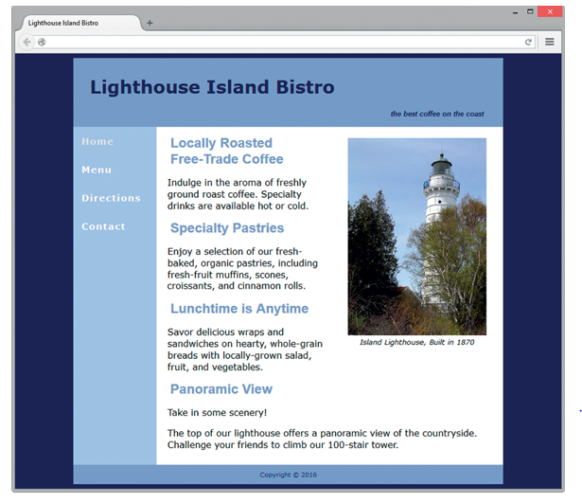

**Figure 8.22 *The two-column desktop display.***

Create a folder named query8. Copy the starter2.html file from the chapter8 folder into the query8 folder and rename it asindex.html. Copy the lighthouseisland.png file from the student files chapter8/starters folder into the query8 folder.

Launch a browser and view index.html as shown in [**Figure 8.22**](https://jigsaw.vitalsource.com/books/9780133971026/epub/OPS/xhtml/fileP70004950620000000000000000027DB.xhtml#P700049506200000000000000000286A). Open index.html in a text editor. Review the embedded CSS and note that the two-column layout is fluid with an 80% width. The two-column look is accomplished by configuring a nav element that floats to the left.

1. Edit the embedded CSS to configure styles for a typical tablet display. Add the following @media rule after the existing style rules but before the ending style tag. The @media rule will configure styles that take effect when the viewport size is 1024 pixels or smaller: eliminate the left margin on the main element and change the float and width properties configured for the nav element selector. The CSS follows:

@media only screen and (max-width: 1024px) {

main { margin-left: 0; }

nav { float: none;

width: auto; }

}

Save the index.html file. Text your index.html file in a desktop browser.

When the browser is maximized, the page should look similar to [**Figure 8.22**](https://jigsaw.vitalsource.com/books/9780133971026/epub/OPS/xhtml/fileP70004950620000000000000000027DB.xhtml#P700049506200000000000000000286A).

When you resize the browser to be smaller (with less than or equal to 1024 pixels), the page should look similar to [**Figure 8.23**](https://jigsaw.vitalsource.com/books/9780133971026/epub/OPS/xhtml/fileP70004950620000000000000000027DB.xhtml#P700049506200000000000000000287D) with a single-column layout. As you can see, we still have some work to do.

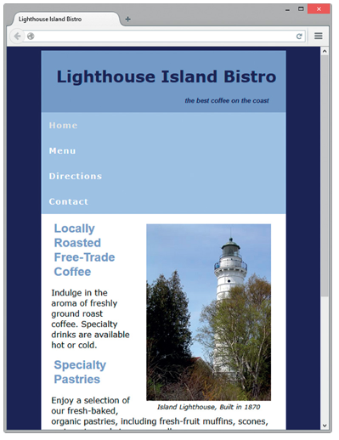

**Figure 8.23 *The media query has been applied.***

1. Continue editing the embedded CSS to configure display for a typical tablet. To allocate the entire viewport to the webpage, add style rules within the media query that remove the margin on the body element selector, and expand the wrapper id.

Create a horizontal navigation area by configuring the nav area li elements with inline-block display and padding, the nav area ul elements with centered text, and the nav area anchor elements with no border.

Also set h1 elements with 120% font size, h2 elements with 120% font size, and p elements with 90% font size. The CSS follows:

@media only screen and (max-width: 1024px) {

body { margin: 0; }

#wrapper { width: auto; }

main { margin-left: 0; }

nav { float: none;

width: auto; }

nav li { display: inline-block;

padding: 0.5em; }

nav ul { text-align: center; }

nav a { border-style: none;}

h1, h2 { font-size: 120%; }

p { font-size: 90%; }

}

Save the index.html file. Test your index.html file in a desktop browser.

When the browser is maximized, the page should look similar to [**Figure 8.22**](https://jigsaw.vitalsource.com/books/9780133971026/epub/OPS/xhtml/fileP70004950620000000000000000027DB.xhtml#P700049506200000000000000000286A).

When you resize the browser to be smaller (a width less than or equal to 1024 pixels), the page should look similar to [**Figure 8.24**](https://jigsaw.vitalsource.com/books/9780133971026/epub/OPS/xhtml/fileP70004950620000000000000000027DB.xhtml#P700049506200000000000000000288E).

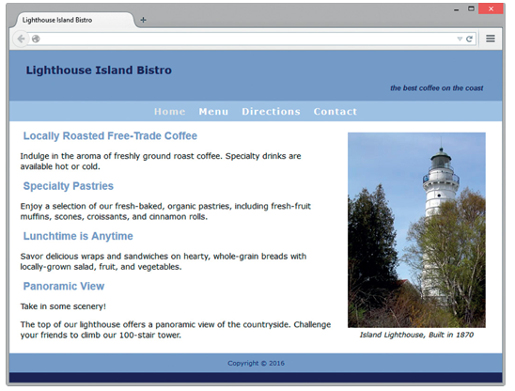

**Figure 8.24 *Configured for a typical tablet.***

Continue to resize the web page and notice that the navigation hyperlinks will shift and are not well aligned. We still have more work to do to optimize the page for display on small mobile devices.

1. Edit the embedded CSS to configure styles for a typical smartphone device. Note that the styles you have already coded in Step 2 will be rendered by the browser for any device with a max-width less than or equal to 1024 pixels (this includes tablets and smartphones). Next, you need to configure additional styles to configure the display needed for smaller devices with a max-width less than or equal to 768 pixels.

To optimize the display on typical smartphone devices: configure styles to prevent the figure element from displaying, decrease the font size for h1, h2, and span elements, and configure vertical navigation that is easy to select by touch (eliminate padding in the navigation area, configure li and anchor elements with block display, configure anchor elements with top padding, bottom padding, and a border). The CSS follows:

@media only screen and (max-width: 768px) {

h1, h2 { font-size: 100%; }

span { font-size: 80%; }

figure { display: none;}

nav, nav ul, nav li { padding: 0; }

nav li { display: block; }

nav a { display: block;

padding: 0.5em 0;

border-bottom: 2px ridge #00005D; }

}

Save the index.html file. Test your index.html file in a desktop browser.

When the browser is maximized, the page should look similar to [**Figure 8.22**](https://jigsaw.vitalsource.com/books/9780133971026/epub/OPS/xhtml/fileP70004950620000000000000000027DB.xhtml#P700049506200000000000000000286A).

When you resize the browser to be smaller (width equal to or less than 1024 pixels and greater than 768 pixels), the page should look similar to [**Figure 8.24**](https://jigsaw.vitalsource.com/books/9780133971026/epub/OPS/xhtml/fileP70004950620000000000000000027DB.xhtml#P700049506200000000000000000288E) with a single-column layout.

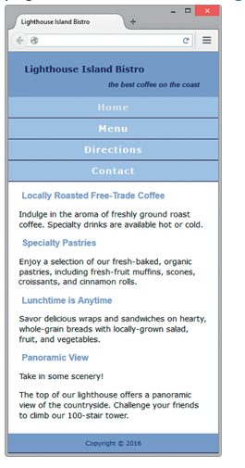

**Figure 8.25 *Typical smartphone display***